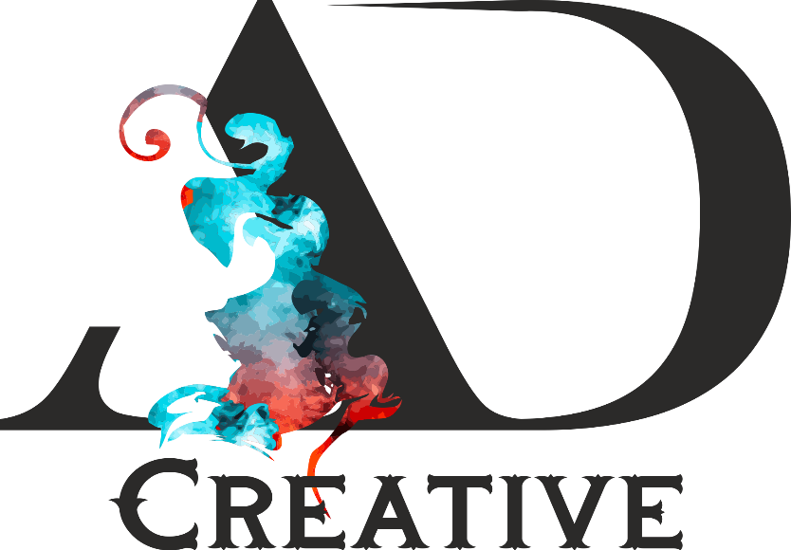

**Hair – Beauty – Makeup Services & Academy**

DATE – 05/12/2023

Re: No Objection Certificate

Dear Sir / Madam:

This is to certify that Miss. **Fiza Rajani** has worked as a **Hair stylist & beautician** at **AD Creative Salon & Academy** from  **(1st September 2022** to **December 5th 2023).**

This NOC has been issued as per the request of the employee and can be used by her for any purpose. During her time with us, she has been a sincere and diligent individual. We wish her good luck.

Feel free to contact us.

**Your Sincerely**

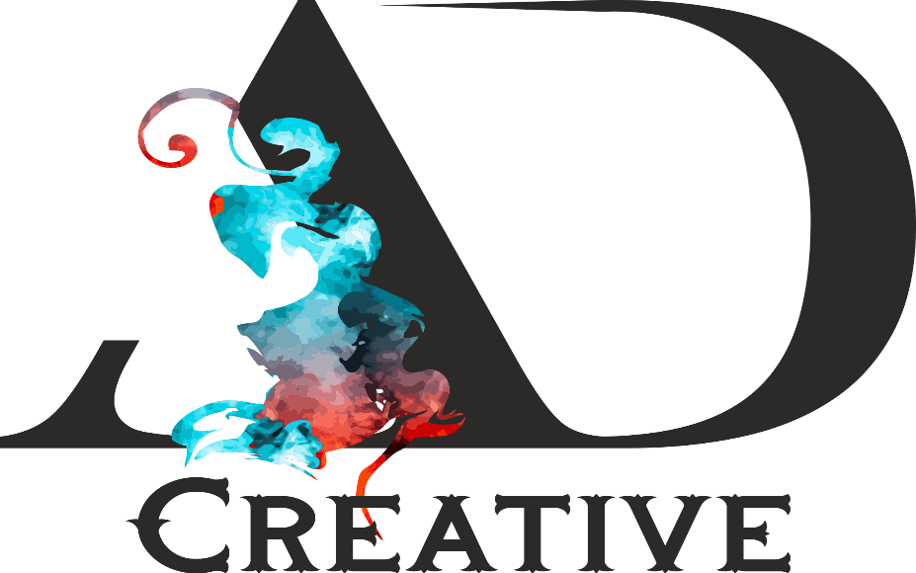

**(Managing Director)**

**# 5-8-220/11, Mount Meru Arcade, Chirag Ali Lane, Abids, Hyderabad 500001.** **Cell: +91-8341772609, Email: - creativead910@gmail.com – Instagram: - @adcreative_salon.**